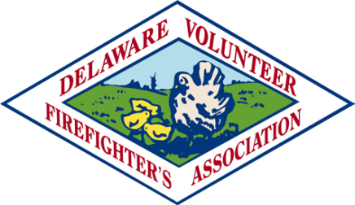



**Delaware Volunteer Firefighter’s and Ladies’ Auxiliary Mutual Relief Association, Inc.**

**CONFERENCE 2025 REGISTRATION**

**MUTUAL RELIEF MEETING WEDNESDAY, SEPTEMBER 24, 2025**

**11:15 A.M. – 12:00 P.M.**

**Rehoboth Beach Convention Center**

COMPANY NAME: _____________________________STATION # ________

PRESIDENT’S NAME: ___________________________PHONE # _________

DELEGATE: _______________________________________________________

ALTERNATE: _____________________________________________________

PLEASE COMPLETE AND RETURN **ONE COPY** OF THE REGISTRATION FORM BY JULY 15, 2025

TO: Mary Alice Maichle 11 Blount Road

New Castle, DE 19720 MJAC28@aol.com

IF YOU HAVE ANY QUESTIONS, PLEASE CALL Mary Alice @ (302) 981-3985